**User Manual**

Disclaimer: Our project currently is a desktop-only game, as the main character is controlled with the arrow keys on the keyboard. A functional dPad to move the character is shown within the scratches but is not implemented into the final project.

Player Movement :

To control the main character, use the 4 arrow keys to move the character in the corresponding four directions around the game map.

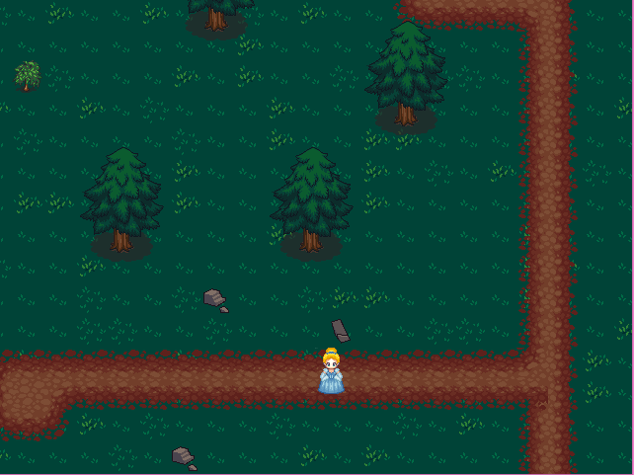

A portion of the game map.

Note: The collision detection with the map obstacles works best when you are moving in only 1 direction at a time. Otherwise you may be able to slide through an object.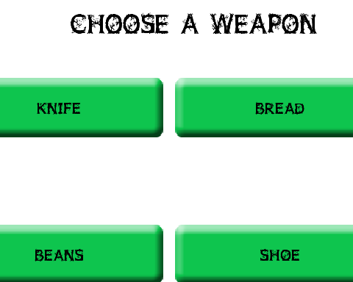

Battles: One the character hits an enemy, you will be taken to the weapons screen where you will choose the weapon you will use in the fight. The current weapon is indicated by an image in the lower right corner.

For the turn-based battle to progress the Attack button must be clicked, and, the witch will automatically attack in retaliation, along with with displaying dialog. The dialog will disappear after a set time and you can continue to attack or switch your weapon of choice.

The main battle screen.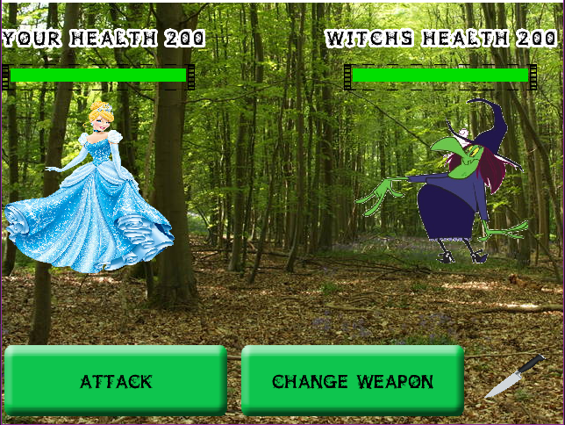

Once the enemy is defeated you will be taken to a win screen with a continue button, that once clicked will return you to the game map with the enemy now removed from the screen, allowing you to continue to the objective and complete the mission.

If you are defeated in battle you will be taken to a lose screen, where clicking the continue button will return you to weapons screen and restart the battle so you can try again.

Objectives: When you begin a level, a message will pop up giving you a objective you must achieve ; in the first level it is get to the festival. Once the objective has been completed, you are taken to the next level and given another objective. To complete the objective, you will have to defeat a boss enemy that stands in your way. Once the boss is defeated, they will disappear and you can continue on your path to completing the objective, as shown in the picture to the right.